DSC 106 HW

Noah Inada

G Suite

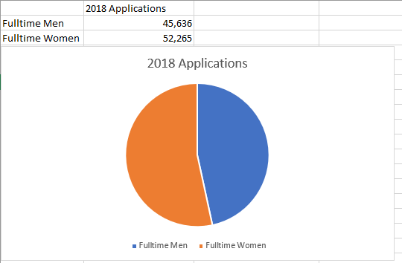

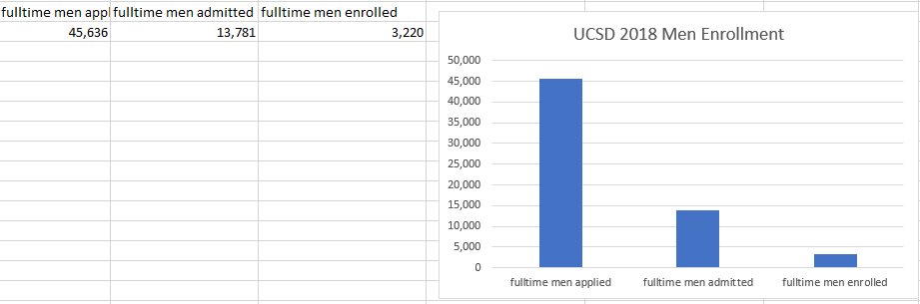

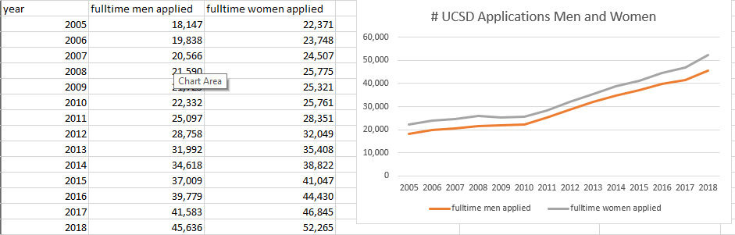

Infogram

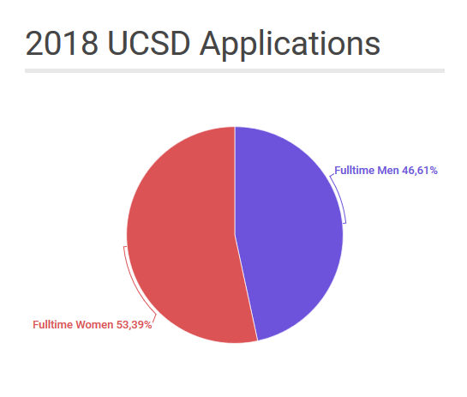

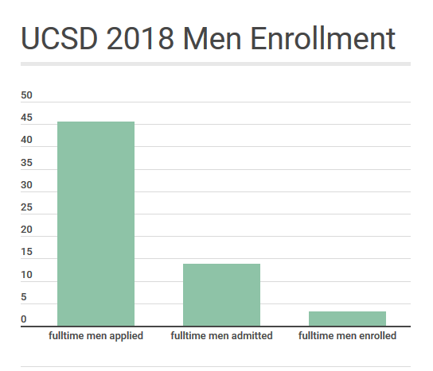

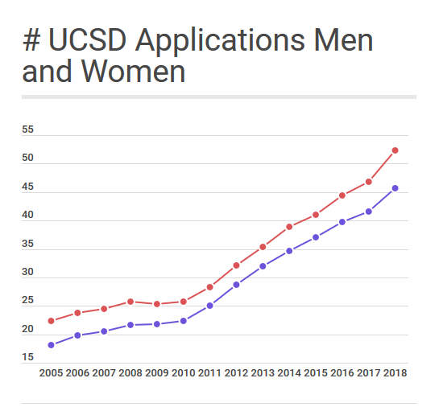

Tableau

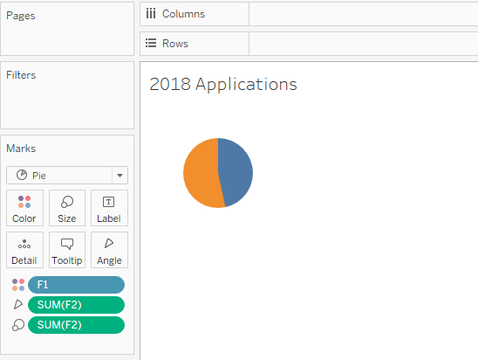

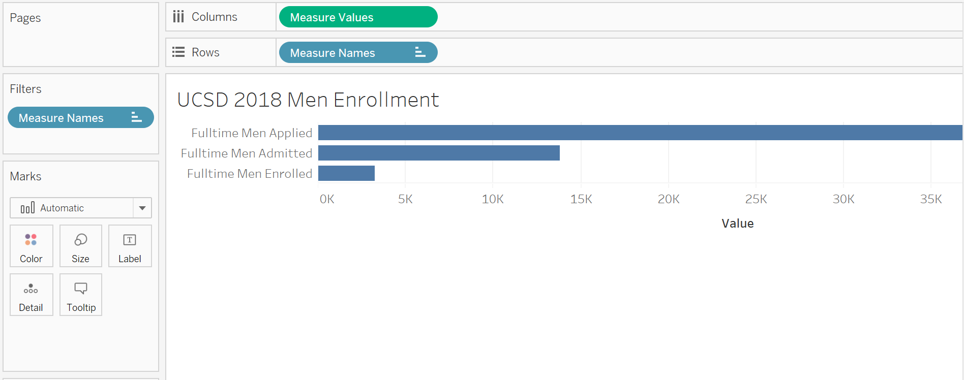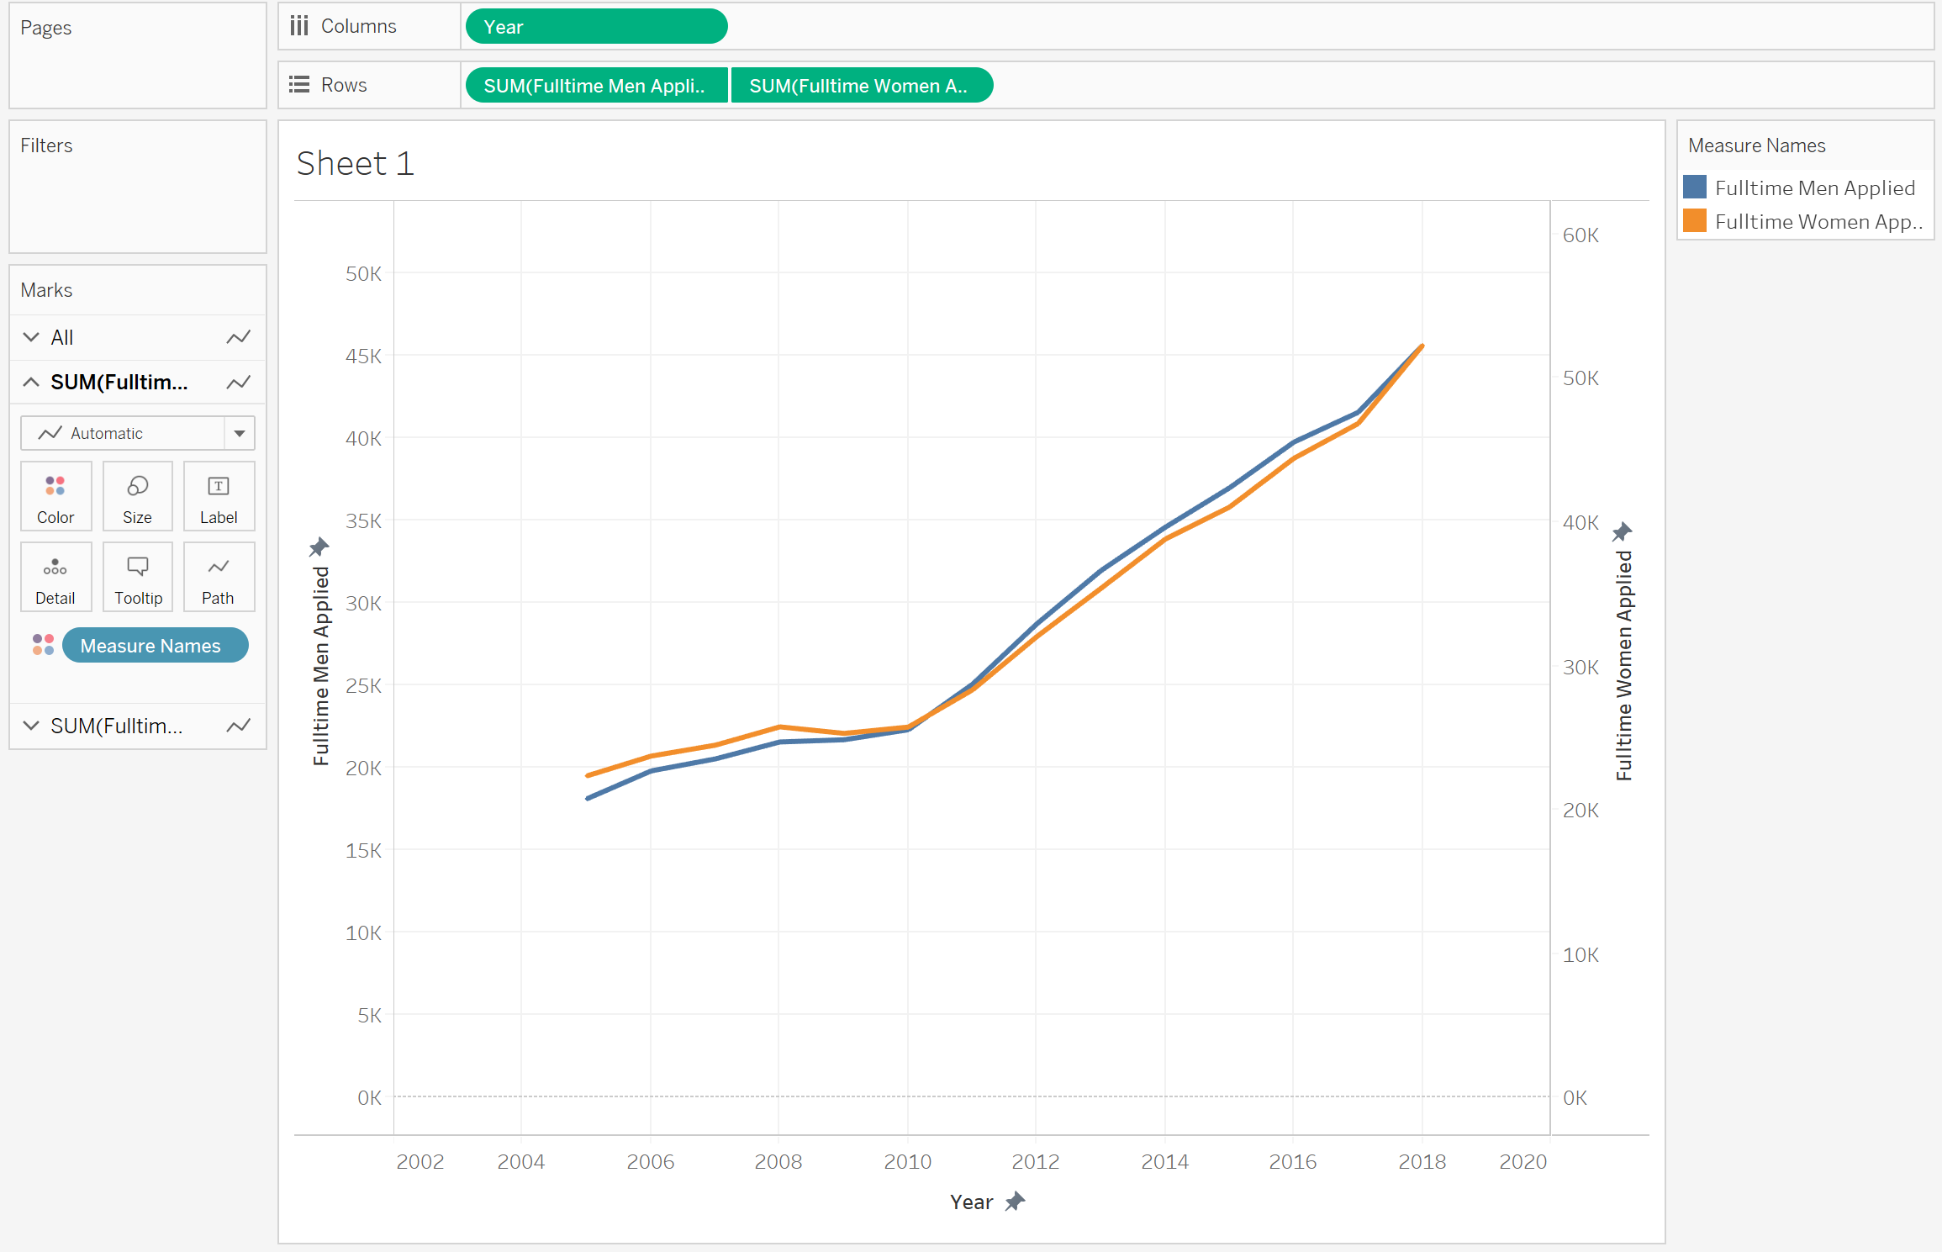

D3

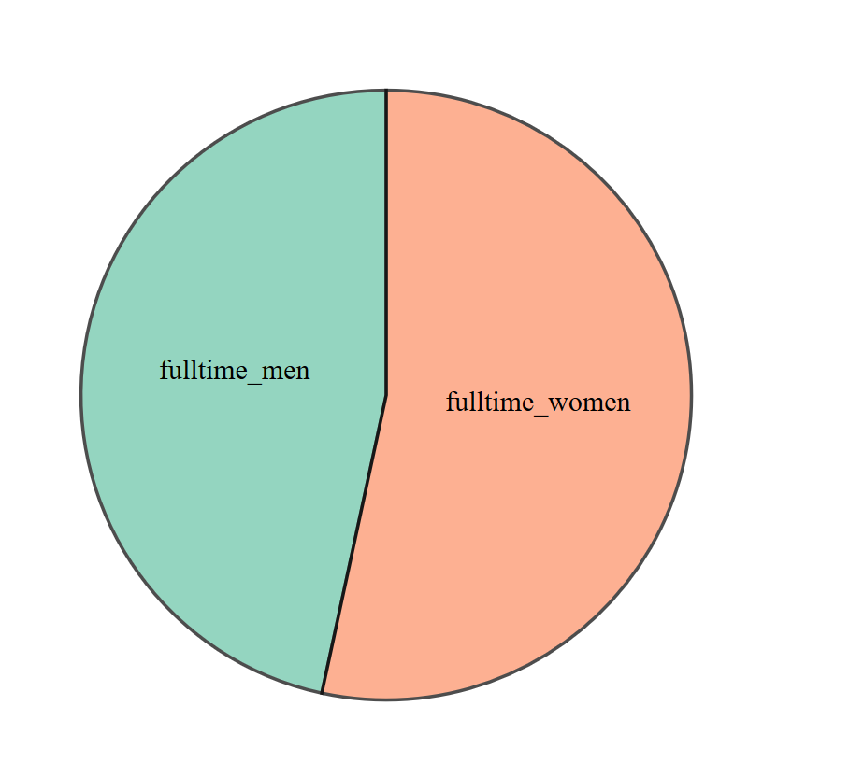

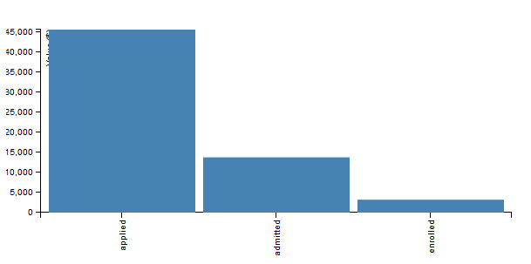

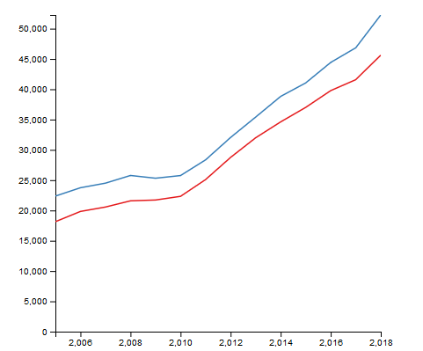

Highcharts

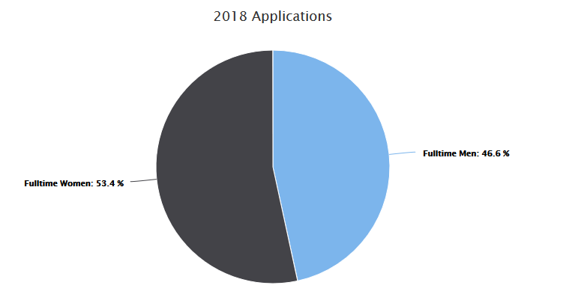

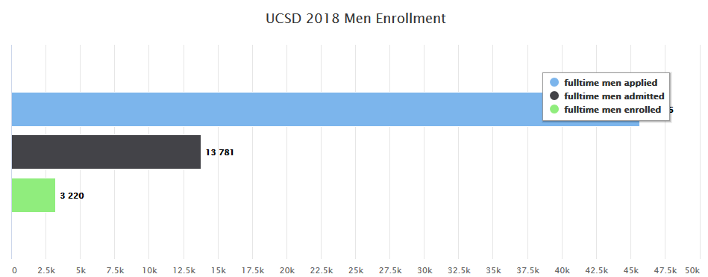

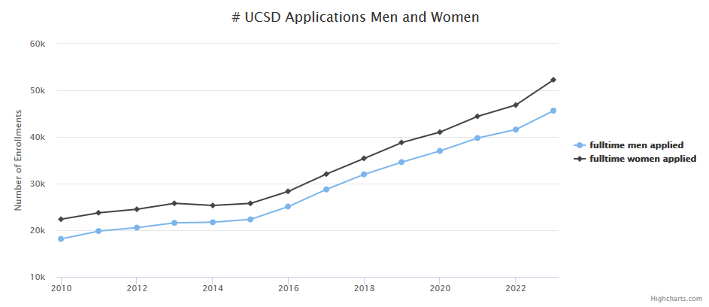

Write-up

Google G Suite

Working with Excel was quick and easy. A pro would be its ease-of-use and quick customizability. A con may be working with large amounts of data and in-depth customization. Also, because the charts can update immediately when data changes, a new graph doesn’t have to be generated every time like it would have to be in Infogram, which is a benefit. A con would be that the visualizations cannot be embedded into browsers like D3 and Highcharts can be.

Infogram

Being used to using Python packages or Excel for visualizations, I was impressed with Infogram. It was even easier than Excel, and the graphs looked great. But they can’t be embedded into browsers like D3 and Highcharts, and they can’t change dynamically like Excel can.

Tableau

Making the line chart was not too difficult, but I got frustrated with this program when trying to create a pie and bar chart. I wish we had spent some time in class quickly going over how to use the program. So an obvious con, at least for me, would be its lack of ease-of-use. Also, I think there may be lots of potential with the program that I could harness if I knew how. I hope that we cover this in lecture or in a discussion section.

D3

Compared, to D3, tableau was a piece of cake.  
Relating to what someone said in class – even when I copied and pasted code from online, it took me a long time to cater the code to my data, and even then, there were errors with the presentation, such as having commas in the year marks. I think D3 is great because it is so customizable and flexible, and you can use code to help you, but it takes a long time to do simple things. Also, it can be embedded into browsers, which can be very useful for websites.

Highcharts

I like Highcharts much more than D3. I don’t really know why anybody would prefer D3, except that maybe you can make more in-depth changes in D3. But I am just assuming that because it is more complicated – but complicated does not necessarily mean more in-depth.  
The visualizations looked better, and they were easier to make. And they seemed to take less code than D3, despite being interactive! I assume this is because it encapsulates more code that D3 does not, but I think that it does it very well. It is not difficult to see what each line of code does in Highcharts, while in D3 the code is more difficult to parse in my head.